**Dashboarding sharing steps**

**NOTE :**

Before sharing a dashboard with other users, it's important to ensure that you have the necessary permissions. You should have the **MONITOR_ADMIN**. Once you have these Roles, you can follow the steps below to share the dashboard with other users.

# **STEP 1 : Grant role Monitor_admin to user , for that refer below command(OPTIONAL)**

| **GRANT** **ROLE** MONITOR_ADMIN **TO** **USER** <USER_NAME>; |
| --- |

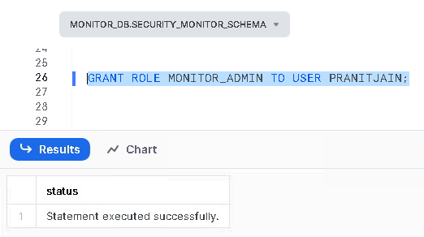

**Note:**

If a user has already been granted with Monitor Admin privileges with whom you want to share the dashboard, then step 1 can be considered **optional**.

# **STEP 2 : Initiation of Dashboards sharing process**

To begin sharing the dashboard, navigate to the dashboard section and select the dashboard you want to share. Make sure that the MONITOR_ADMIN role is selected and the MONITOR_WH warehouse is chosen.



# **STEP 3 : Sharing**

Next, click on the **"Share"** button and search for the user with whom you want to share the dashboard. Once you have found the user, select them and then choose the level of access you want to grant them, such as **"view+run," "view," or "edit."**



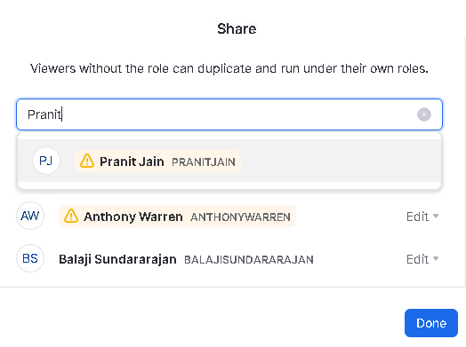

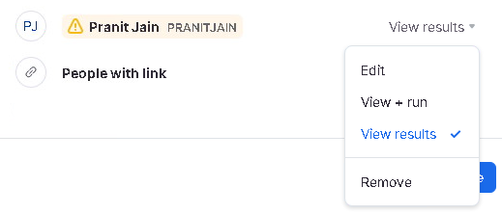

**Note:**

If you are unable to find a user after clicking on the **"Share"** button and searching for them, it is possible that they have never logged into the Snowflake instance. In such cases, it is important to ensure that any users who are granted access to the dashboard have logged into Snowflake at least once. This will ensure that their account is active and that they are able to receive the necessary permissions to access the dashboard.

# **STEP 4 :** For all the respective dashboards , you can follow the STEP 3 inorder to share with required access.

# **Point to Remember:** To ensure that shared dashboards are viewed correctly, it's important to limit access to only those with the monitor admin role. Changing this role to view KPIs can result in other users seeing locked tiles if they don't have additional roles beyond monitor admin. Therefore, the best practice is to share dashboards exclusively with **monitor admins** and avoid making any changes to their role.